

**MZUMBE UNIVERSITY**

**FACULTY OF SCIENCE AND TECHNOLOGY**

**COURSE NAME: SYSTEM ANALYSIS AND DESIGN**

**PRORAMME: BSc. ITS 2**

**TASK: GROUP ASSIGNMENT**

**COURSE CODE: CSS 213**

**GROUP MEMBERS**

|  |  |  |
| --- | --- | --- |
| **S/NO** | **STUDENT’S NAME** | **REG.NO** |
| **01** | **THERESIA M. KABUCHE** | **14322051/T.20** |
| **02** | **RENATUS M. PIUS** | **14322049/T.20** |

**QUESTION 1:**

1. Describing use cases that represents those three functions.

* Use case 1.

Check out books.

* Primary actors:

Customer.

* Description:

This use case starts after the customer has logged in and starts checking the available books in the library

* Use case 2.

Sign up a new borrower

* Primary actors:

Customer

* Secondary actor:

Librarian

* Description:

This use case starts when a customer selects a book and wants to borrow it

* Use case 3.

Send overdue notice

* Primary actors:

Librarian

* Description

This use case begins when a borrower or customer does not return a book in the directed time and Librarian wants to send overdue notice to those borrower.

1. The use case diagram for Library system.

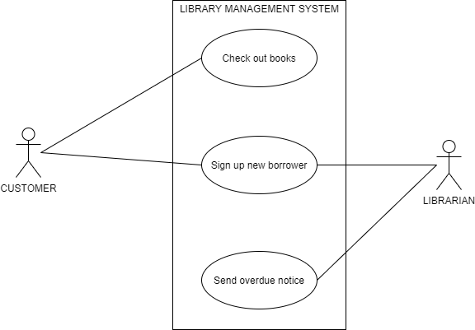

1. A sequence diagram for **Sign up a new borrower** as a selecteduse case.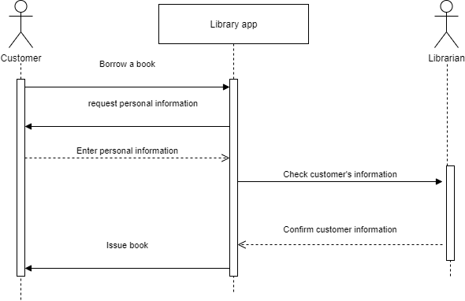
2. A class diagram for library system.

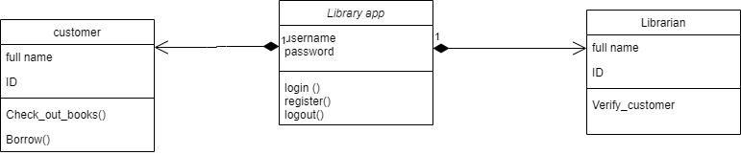

**QUESTION 2:**

1. Description of Admit student use case are illustrated below.

* The given use case:

Admit student

* Use case’s description.

This use starts when the admissions coordinator wants to inform an applicant that they are admitted or not

* Primary actor.

Admissions coordinator

* Secondary actor.

Applicant

* Pre-conditions.

The applicant must have paid for the application fee and

the admission coordinator must have evaluated the application form

* Post-conditions.

The applicant should be informed whether they are admitted or not

1. A use case diagram for Student Admission System.

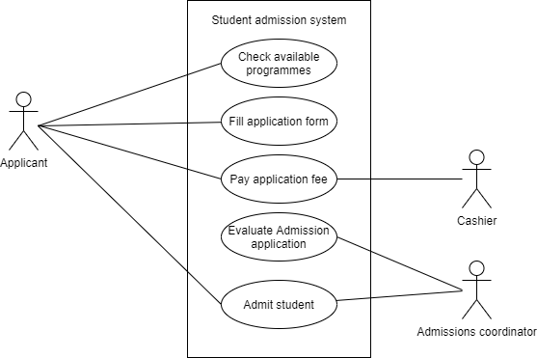

**QUESTION 3:**

A system analyst can handle the changes of a requirement of a system through

1. Understanding the reason for the change.
2. Understanding the impact of the change.
3. Understanding the effort required to implement the change.
4. Ensuring that the change request follows the predetermined approval process.

**QUESTION 4.**

How can you say a requirement is good or perfect

1. Complete: The individual requirement is not missing necessary or relevant information. Additionally, the entire set of requirements should cover all relevant requirements.
2. Consistent: The requirement does not contradict another requirement.
3. Modifiable: Like requirements should be grouped together to allow similar requirements to be modified together in order to maintain consistency.
4. Correct: The requirement meets the actual business or system need. An incorrect requirement can still be implemented resulting in a business process or system that does not meet the business needs.
5. Observable: The requirement defines an aspect of the system that can be noticed or observed by a user. This is often referred to as “Implementation Agnostic” as the requirement should not specify aspects of system architecture, physical design or implementation decisions. These aspects of a system should be defined separately as constraints.
6. Feasible: The requirement can be implemented within the constraints of the project including the agreed upon system architecture or other physical design or implementation decisions.
7. Unambiguous: The requirement is written objectively such that there is only a single interpretation of the meaning of the requirement.
8. Verifiable: It can be shown that the requirement has been met by the final solution via inspection, demonstration, test, or analysis.

**QUESTION 5.**

A business analyst says the requirements are done when all the stakeholders have approved those requirements.

**QUESTION 6.**

Benchmarking is an approach of setting goals and measuring productivity based on best system practices. Benchmarking helps in improving performance by learning from best practices and the processes by which they are achieved.